- What is the process approach?
- What is the flow of food?
- What are the three food preparation processes most often used in retail and food service establishments?

APPLYING HACCP PRINCIPLES TO RETAIL AND FOOD SERVICE

What is the process approach?
Since the early 1980’s, retail and food service operators and regulators have been exploring the use of HACCP in restaurants, grocery stores, and other retail food establishments. Most of this exploration has centered on the question of how to stay true to the definitions of HACCP yet still make the principles useful to an industry that encompasses a very broad range of conditions. Through this exploration, HACCP principles have been slightly modified to apply to the varied operations found at retail. When conducting the hazard analysis, food manufacturers usually use food commodities as an organizational tool and follow the flow of one product. This is a very useful approach for producers or processors since they are usually handling one product at a time. By contrast, in retail and food service operations, foods of all types are worked together to produce the final product. This makes a different approach to the hazard analysis necessary. Conducting the hazard analysis by using the food preparation processes common to a specific operation is often more efficient and useful for retail and food service operators. This is called the "Process Approach" to HACCP. The process approach can best be described as dividing the many food flows in an establishment into broad categories based on activities or stages in the flow of food through your establishment, then analyzing the hazards, and placing managerial controls on each grouping. back to top

What is the flow of food?
The flow of food in a retail or food service establishment is the path that food follows from receiving through service or sale to the consumer. Several activities or stages make up the flow of food and are called operational steps. Examples of operational steps include receiving, storing, preparing, cooking, cooling, reheating, holding, assembling, packaging, serving, and selling. Keep in mind that the terminology used for operational steps may differ between food service and retail food store operations.

What are the three food preparation processes most often used in retail and food service establishments?
Most food items produced in a retail or food service establishment can be categorized into one of three preparation processes based on the number of times the food passes through the temperature danger zone between 41 ºF to 135 ºF:

Process 0: No Food Preparation and No Cook Step
Example flow: Receive – Store – Hold – Serve
(other food flows are included in this process, but there is no cook step to destroy
pathogens)

Process 1: Food Preparation with No Cook Step
Example flow: Receive – Store – Prepare – Hold – Serve
(other food flows are included in this process, but there is no cook step to destroy
pathogens)

Process 2: Preparation for Same Day Service
Example flow: Receive – Store – Prepare – Cook – Hold – Serve
(other food flows are included in this process, but there is only one trip through
the temperature danger zone)

Process 3: Complex Food Preparation
Example flow: Receive – Store – Prepare – Cook – Cool – Reheat – Hot
Hold – Serve
(other food flows are included in this process, but there are always two or more
complete trips through the temperature danger zone)

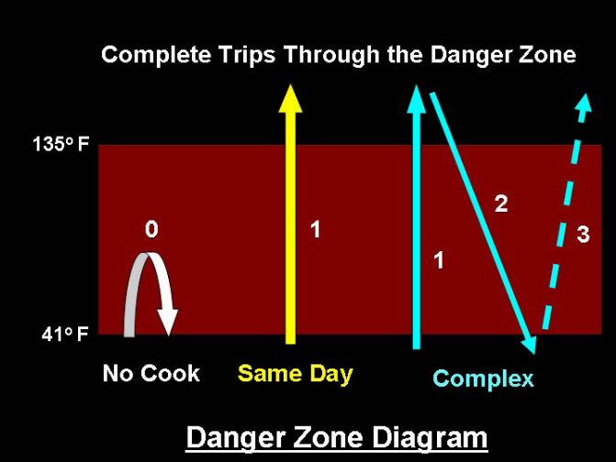

A summary of the three food preparation processes in terms of number of times through the temperature danger zone can be depicted in a Danger Zone diagram. Note that while foods produced using process 1 may enter the danger zone, they are neither cooked to destroy pathogens, nor are they hot held. Foods that go through the danger zone only once are classified as Same Day Service, while foods that go through more than once are classified as Complex food preparation. The three food preparation processes conducted in retail and food service establishments are not intended to be all-inclusive. For instance, quick service facilities may have “cook and serve” processes specific to their operation. These processes are likely to be different from the “Same Day Service” preparation processes in full service restaurants since many of their foods are generally cooked and hot held before service. In addition, in retail food stores, operational steps such as packaging and assembly may be included in all of the food preparation processes prior to being sold to the consumer. It is also very common for a retail or food service operator to have a single menu item (i.e. chicken salad sandwich) that is created by combining several components produced using more than one kind of food preparation process. It is important for you to remember that even though variations of the three food preparation process flows are common, the control measures – actions or activities that can be used to prevent, eliminate, or reduce food safety hazards – to be implemented in each process will generally be the same based on the number of times the food goes through the temperature danger zone.

